Date : 28-Feb-2026
Roadmap - ﻿https://sdet.live/roadmap-ai
Topics - ﻿https://sdet.live/ai-topics

Class -01 :

- Local LLM Setup
- Cloud AI - Groq Setup
- IDE Setup
  - VS Code with github co pilot
  - Antigravity
- Github Account Setup
- LangFlow & n8n Setup.

1.Community →https://www.sdetclub.com/c/ai-tester-2x-only/
Name : yarlagaddawork27@gmail.com
Pass : gmsvPLRBS@123

2.Action Plan for the 12+ Weeks
Roadmap - ﻿https://sdet.live/roadmap-ai
Topics - ﻿https://sdet.live/ai-topics

3.Sequence to follow.
- LLM Basics
- Prompts Eng
- Generative AI
  - Resume, LinkedIn + AI
  - Claude Code, Github copilt, Antigravity->
- AI Agents
  - Langflow
  - n8n
  - Basic Python
  - Langchain
  - Crew.AI (production ready AI Agent creator)
- MCP
- RAG
- STLC with AI
- AI with the PW, Selenium, API Testing
- LLM Evaluation / LLM Testing
  - Deepeval, prompt foo, Trulens
  - open AI Eval
- Projects (Built with AI -> 25+ Projects + Github (upload) profile.

Create FREE account.
- ﻿track.thetestingacademy.com/
Future - ﻿app.thetestingacademy.com/

- GitHub account :
https://github.com/PramodDutta

=====================================================================

SDET CLUB, Bi weekly Friday - 8 PM IST -> 1 year -> You will be always - updated.
- New Tools
  - OpenClaw
  - Codex, Claude Code, Github CLI.
We will keep covering them also even after the 12+ weeks. (Bi weekly Friday Extra classes) - 1 Year

==============================================================
Topics / Curriculum
﻿docs.google.com/spreadsheets/d/1utAR1QGRZKI2M_rZTwpC6dELI3eBTvyOoo6SRGp4E2A/edit?usp=sharing

==================================================================

How to access the courses ? (Recordings)
- Make sure that the you have a reset password -
﻿courses.thetestingacademy.com/password/reset
- Access the all the courses here - ﻿courses.thetestingacademy.com/mycourses
AIATB also in the list.
====================================================================

How to Ask the Doubts, Get the Task and Discuss my problem?
- Task #1 - ﻿www.sdetclub.com/c/ai-tester-2x-only/task-28th-feb-2026-introduce-yourself
- Task #2 -> ﻿www.sdetclub.com/c/ai-tester-2x-only/task-28th-feb-2026-installation-of-tools
- Doubts -> ﻿www.sdetclub.com/c/ai-tester-2x-only/doubts-28-feb-2026-introduction-class

========================================================================
SDETClub Access on the mobile
﻿apps.apple.com/us/app/circle-communities/id1509651625
﻿play.google.com/store/apps/details?id=so.circle.circle&utm_source=community_nav

=================================================================
- SDET Club - Task and Updates and Doubts ( You can ask question here, this private community).
- ﻿Courses.thetestingacademy.com - Recordings
- WhatsApp community - Reminder (for the class reminder) - Not using it further. (WhatsApp No Group)
========================================================================SDET Club Masterclass - (Lifetime) - Biweekly - Friday Evening 8 PM IST.
- Recordings - ﻿courses.thetestingacademy.com/courses/sdet-club-masterclasses-1337/dashboard
===========================================================================

How to see the recording
﻿https://www.loom.com/share/f52b39bc9095470ea0902075fe169e26?sid=564ed0c2-74ee-45c8-9acb-a6477b9669eb

==========================================================

Required Access
﻿https://forms.gle/L47EKJns4ZPobLUH6
- ﻿SDETclub.com (only fill with phone)
- SDET Masterclass

Github Account Setup
﻿github.com/signup

NodeJS (latest version)
﻿nodejs.org/en/download

Visual Studio Code
﻿code.visualstudio.com/download
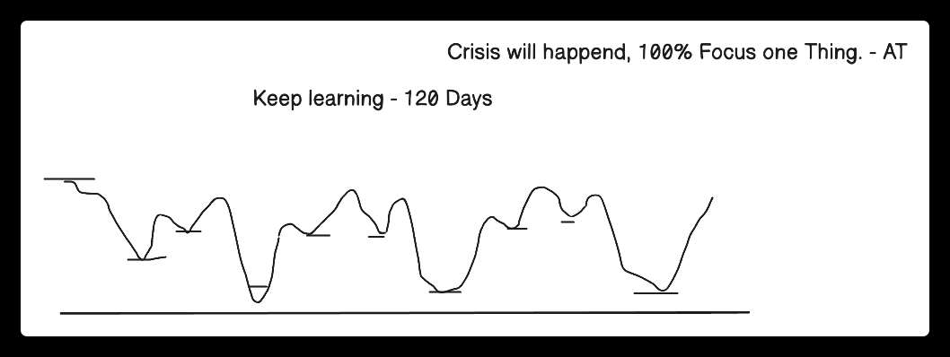

Rules of Life
- 100% Focus on One Thing -> AI Ready Tester -> All of the 100% efforts. (4 hours per week).
- 5% (Execution) and 95% (Plan) ->(Reverse) 5% Plan -> 95% Execution-> Try and Fail -> Try Again ->Success.
  - Test
  - Taking class
  - Github
  - Creating own notes
  - Researching
  - Hands oN
- 50-70% is Perfect -> 100% is Failure - 25K + companies
  - 40-70% Ready -> Interviews
  - Unlimited Oppor. -> Delhi, NCR, Bangalore, Chennai, Pune, -> 25K companies.
- New Actions -> Whatever worked in past, will not work in future. New Skills - G
  - keep up skills
  - Manual Tester 15+ year -> git ?

Financial Knowledge
- Emergency Fund -> monthly - 20k x 6 months -> 1.2L ( FD, Bank) - Save Job Security.
- Health Insurance
- Term Insurance
- 4.SIP - MF - Investing (5-10%) per month, - without -> index Nifty


Class -02 : AI BASICS

Date : 1-Mar-2026

🤖 AI Tester Blueprint

Foundation Models
🧠 What Changed After 2020 – The Era of Scale
Before 2020, AI models were like smart calculators – good at one thing. After 2020, AI models became like super interns – they can write, read, code, explain, summarize, and even reason.

Real-World Example
- Old AI: A spam filter only tells you "spam or not"
- New AI: Can read the email, explain why it is spam, rewrite it professionally, and suggest a reply.

Two Major Consequences of Scale
- Capability Explosion
  - Models can now perform many tasks well
  - New applications became possible (coding, writing, planning, vision)
- Model-as-a-Service Emergence
  - Training large models is expensive and centralized
  - A few organizations build models
  - Everyone else consumes them via APIs
➡️ Result: AI application demand increased while entry barriers dropped.

🤖 What Is AI Engineering?
AI Engineering = Building applications on top of existing foundation models.
⚠️ Using powerful pre-built AI brains to solve real problems == AI Engineering.
You are not training the brain from scratch.
You are:
- Giving it instructions
- Giving it context
- Checking its answers
- Connecting it to real systems

Why AI Engineering Is Growing Fast
- Powerful models already exist
- APIs make usage simple
- Minimal infrastructure required
- Even non-engineers can build AI apps.

============================
Traditional ML Engineer:
- Collects 1M records
- Labels data
- Trains a model
- Tunes hyperparameters
AI Engineer:
- Chooses GPT / Claude / Gemini
- Writes prompts
- Adds documents via RAG
- Evaluates responses
- Deploys fast
This is why AI Engineering feels faster and more creative.

============================================
ChatGPT - Chat application which is using a private LLM - GPT 5.2
claude.ai -> chat application Sonu 4.6, Opus 4.6
Gemini - 3.1
Claude Code, Kimi Code, Codex, Amazon Q, Kili IDE, Cursor, Windsurf - Github Copilot -> ? LLM? ( This is a AI Coding assistant) (AI Agent)
Antigravity - IDE + Agent
Perplexity ->. Curation of multiple models, it uses a algo(AI Agent). which select which model you can use for the which purpose. .
=============================================
From Language Models to Large Language Models (LLMs)
What Is a Language Model? A language model is like autocomplete on steroids.
cat will sit on _

A language model:
- Learns statistical patterns of language.
- Predicts the next token given context
﻿platform.openai.com/tokenizer

What is the Context?
- Information
- Reference, Objective.
- Some information what we are discussing
- background information
"My favorite color is ___"

===================================

Tokens (Very Important)
- Token = basic unit (word, sub-word, or character)
- Models don’t see words, they see tokens.
Why tokens?
- Capture meaning better than characters
- Smaller vocabulary than words
- Handle unknown/new words.
Ask - Give me the source code for the hello world in javascript.
Ask 2- hello world in javascript.

======================
Paper - ﻿arxiv.org/html/1706.03762v7
Attention is all you need ( ~2014)
Give me the source code for the hello world in javascript.
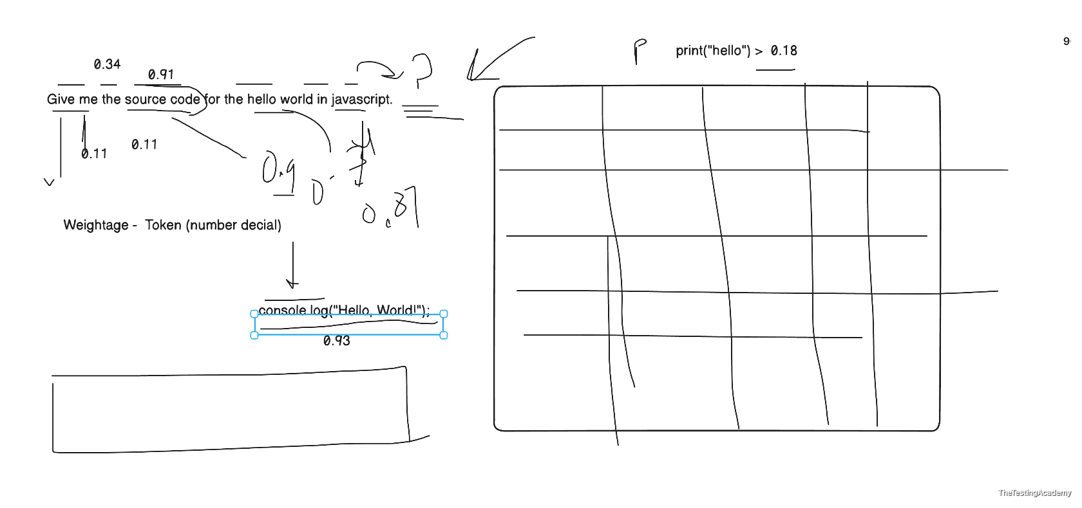

GPT 2 - Was trained - ﻿Reddit.com Forum where people discuss topics and problems.

Two Types of Language Models

1. Masked Language Models (BERT-style) -> my - color is black
Masked Model (BERT) = Fill in the blanks in an exam paper
- Predict missing tokens anywhere
- Uses left + right context
- Best for understanding tasks
Examples:
- Sentiment analysis
- Classification
- Code understanding
﻿https://www.geeksforgeeks.org/nlp/masked-language-models/

my _ color is black
“Playwright is a MASK automation tool.”
“Playwright is a browser automation tool.”

2. Autoregressive Language Models (GPT-style)
Autoregressive Model (GPT) = Write an essay one word at a time
- Predict next token only
- Generate text sequentially
- Best for generation
Examples:
- ChatGPT
- Code generation
- Writing, summarization
➡️ We mainly focuses on autoregressive models
My eye color is black, blue, borwn....
“Playwright is a”
“Playwright is a modern end-to-end testing framework that supports Chromium, Firefox, and WebKit.”

GPT -> Generative Pre Trained Transformer.
data

A language model:
- Learns statistical patterns of language.
- Predicts the next token given context

Paramaters
Parameters in Large Language Models are the internal weights and biases that the model learns during training.

More Parameter have you better. LLM

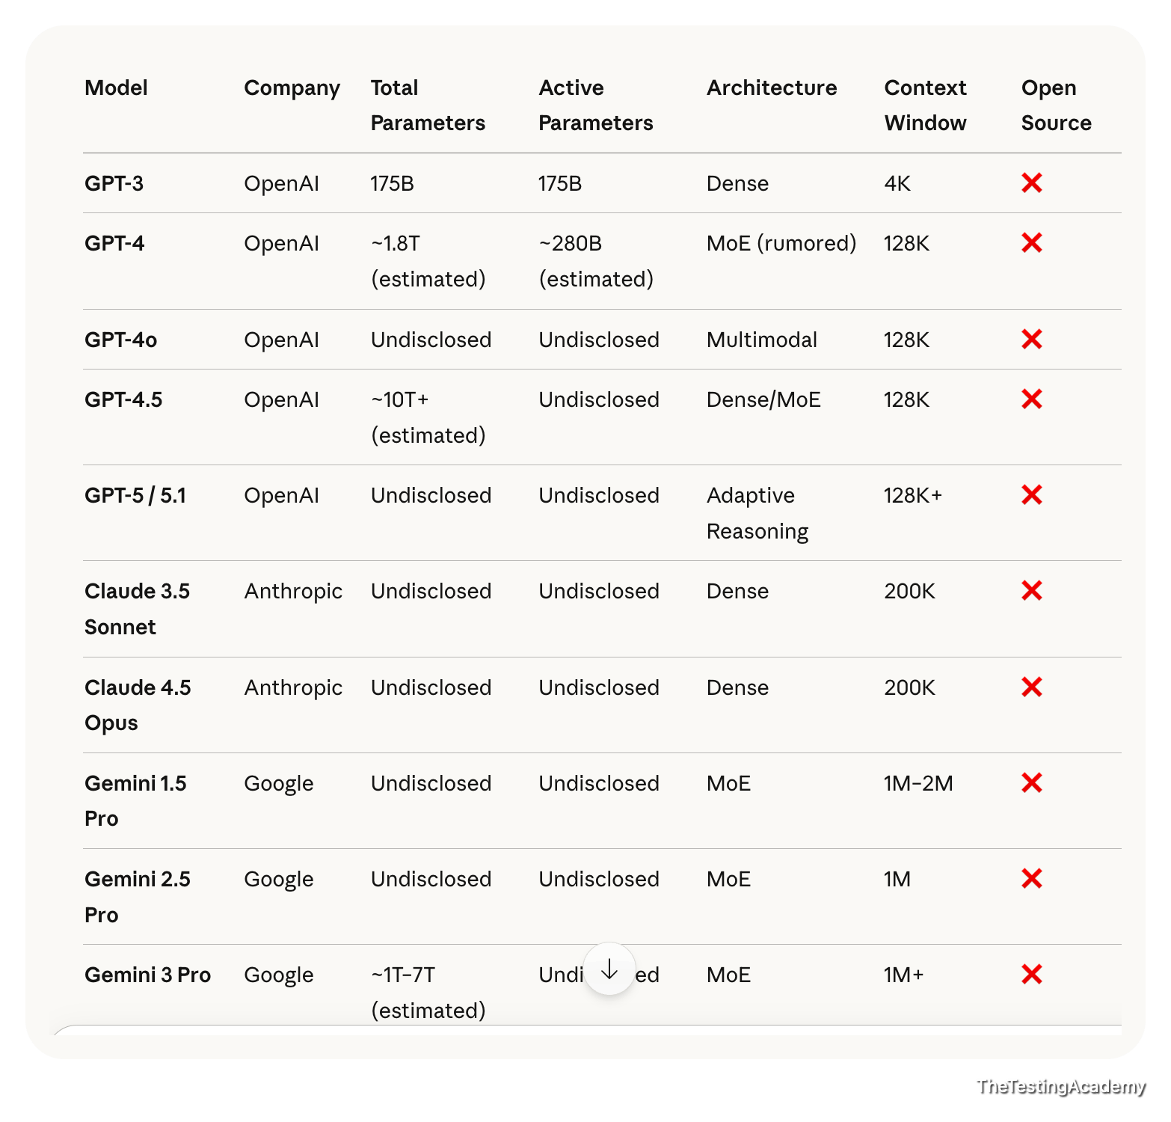

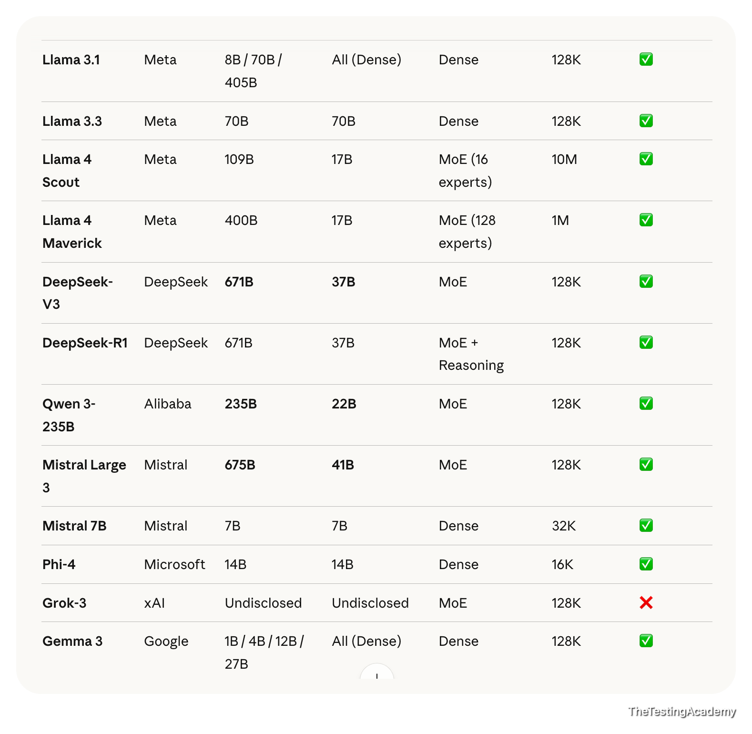
Large Language Model > 1B Large
Small Language Model < 1B (SLM)

Closed Source LLM
- GPT 5.2
Open Source LLM
- Mistral

Visual Studio with Github Copilot (5%)
﻿GROQ.com -> Host the Opensource Models
﻿huggingface.co/models
- openai gptoss 120B - as Good as GPT 5
- llama 3.4,4 -> latest - Good to use.

Generative AI = Completion Machines
Does Playwright support mobile gestures?
Possible Output: "Yes, introduced in version 0.47"

Hallucinations (LLMs “Making Things Up”)

Definition
A hallucination occurs when an AI model produces confident but factually incorrect or completely fabricated output, even though the information does not exist in the system, logs, API, or requirements.
The key danger: the answer sounds correct.

QA Example 1 – Bug Report Hallucination
Prompt to AI
“Analyze this screenshot and generate a Jira bug report.”
AI Output (Hallucinated)
- Error Code: AUTH_403_INVALID_TOKEN
- Root Cause: Token expiry after 15 minutes
- Affected API: /auth/refresh
Reality
- Screenshot only shows “Something went wrong”
- No error code visible
- No token logic involved
Why this is a hallucination
- AI invented technical details
- No evidence in input
- Over-confident explanation

QA Example 2 – Test Case Hallucination
Prompt
“Generate test cases for VWO dashboard.”
AI Output
- Test case: Verify Dark Mode toggle
- Test case: Validate Export to CSV
Reality
- No Dark Mode
- No Export feature in product
Feature hallucination
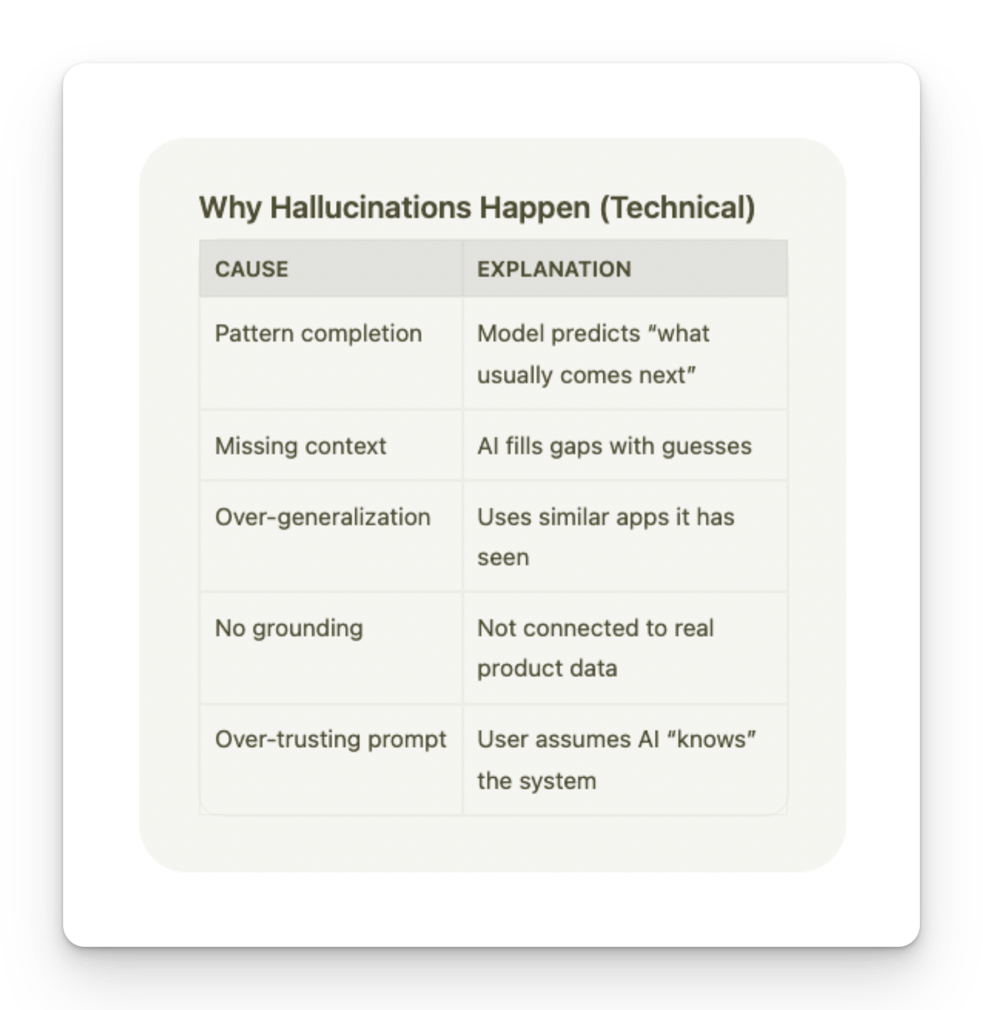

QA Red Flags for Hallucinations
- Mentions features not in PRD
- Invents error codes
- Claims logs show X (without logs)
- Gives exact numbers without evidence
Sounds too certain without sources

Anti-Hallucination Rules
ROLE: You are a QA assistant operating under strict verification rules. SCOPE OF KNOWLEDGE You may ONLY use information explicitly provided in: PRD API documentation Logs Screenshots Test data User input STRICT RULES (MANDATORY) DO NOT invent features, APIs, error codes, UI elements, or behavior. DO NOT assume default or "typical" system behavior. If information is missing or unclear, respond with: "Insufficient information to determine." Every assertion must be traceable to provided input. If a detail is inferred, label it explicitly as: "Inference (low confidence)". Output must be deterministic and repeatable. PROCESS YOU MUST FOLLOW Step 1: Extract verifiable facts from the input. Step 2: List unknown or missing information. Step 3: Generate output ONLY from Step 1 facts. Step 4: Perform a self-check for hallucinations or contradictions. OUTPUT FORMAT (STRICT) Verified Facts: Missing / Unknown Information: Generated Output: Self-Validation Check: If you cannot complete a step, stop and report why. >> Instructions
Bad EXAMPLE
﻿chatgpt.com/share/69a3c1a9-3ed0-8009-969c-9dd3a7cce824
Good Example
PRD - ﻿docs.google.com/document/d/1GsT57ocl4HaUCxNhBGVmwvLYh7R24gjVB_RDteltkF4/edit?usp=sharing
﻿chatgpt.com/share/69a3c2d9-1f40-8009-98ed-6e04598199b4
Anti HALLCINATIONS Rule
﻿github.com/PramodDutta/AI-Tester-Blueprint/blob/main/chapter_01_foundation_model/rules_checklists/ch_01_anti_hallucination.md
﻿groq.com/pricing
GROQ -> CURATION FOR OPEN SOURCE MODELS THAT THEY HAVE HOSTED for you, cheapter models company.
GROK -> elon LLM

﻿arena.ai/leaderboard

